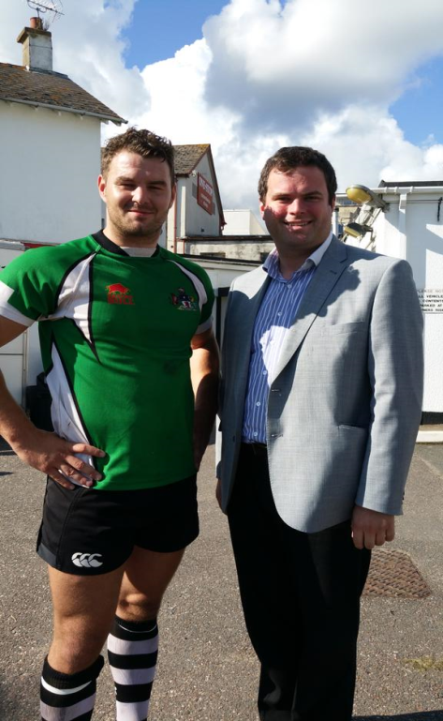



Your local Member of Parliament working hard for Torbay

**Advice Surgeries July 2017**

**Saturday 15th July 11am – 1pm**

Dot’s Pantry, 118 Union Street Torquay, TQ2 5QB.

**Friday 21ST July 3pm – 5pm**

Room 13, Paignton Library, Great Western Road, Paignton TQ4 5AR

**Saturday 29th July 11am – 1pm**

Torquay Library, Lymington Road, Torquay TQ1 3DT

**Friday 4th August 9.15am – 12pm**

5 – 7 East Street, Torquay TQ2 5SD



Please book an appointment to avoid disappointment.

**CONTACT KEVIN FOSTER MP:**

**Tel:** 01803 214989

**Web:**kevinjfoster.com/contact

**Facebook:** KevinForTorbay

**Twitter:** @kevin_j_foster

**Office:** 5-7 East Street, Torquay, TQ2 5SD